**Table of Contents**

**General**

1. Data Governance Framework Abstract

* Mission
* Purpose

1. Data Governance Framework Integration Scope
2. Data Governance Integration Models and Charts

* System Integration Model
* Database Integration Chart
* Telephone Commerce Model

**Definitions**

1. Data Governance Framework Definitions
2. Data Governance Framework Acronyms
3. Data Governance Framework Layers

* Data Governance Office

1. Policies
2. Requirements
3. Goals

* Data Stakeholders
* Data Stewards
* Business Intelligence Team

1. Data Governance Integration – Homologation procedures

* Business Intelligence Processes
* Capture Processes
* Mod / Boot Processes
* Transactional Processes
* Validation Processes

1. Data Governance Integration – Normalization procedures

* Data Rules and Definitions
* Exceptions and Exceptions Handler
* Variables Set definitions
* Variables Set Type – Usage
* Variable Set Automate Conversion
* Variable Set Sub-Automate Conversion

1. Data Governance Integration – Controls

* Decision Rights
* Integrated Accountability
* Control Methodology
* Issue Resolutions

1. Data Governance Integration – Usage

* Variables Definition and Parameter Settings
* Sprints Plan
* Development Plan and Software Foundations
* Solution design
* AB Test
* Software Deploy
* Data Capture and Management
* Crystal Reports

**Standardized Operational Procedures**

1. Database Creation Procedure

* IPO Model
* Flowchart

1. Database Mod / Boot Procedure

* IPO Model
* Flowchart

1. Database Query / Export Procedure

* IPO Model
* Flowchart

1. Database Transactional Procedures

* Conciliation IPO Model
* Transactional IPO Model
* Validation IPO Model
* Flowcharts

1. IT Software Integration Procedure
2. IT Software Variable definition Procedure
3. BI Process and Procedures

* IPO Model
* Flowcharts

**Team Standardized Operational Procedures**

1. Chief Technology Officer SOP

* Scope
* Duties
* Responsibilities

1. Chief Data Officer SOP

* Scope
* Duties
* Responsibilities

1. IT Project Manager SOP

* Scope
* Duties
* Liability
* Responsibilities

1. Chief Data Officer SOP

* Scope
* Duties
* Liability
* Responsibilities

1. Scrum Master SOP

* Scope
* Duties
* Responsibilities

1. BI Director SOP

* Scope
* Duties
* Responsibilities

Crystal Report and Telemetry

1. Data Telemetry

* Accesses
* Exceptions
* Usage
* Restrictions
* Validations

1. Crystal Reports

* Data Accuracy
* False Queries
* Transactions
* Transfer Rate
* Violations

Layer Model

**Integration Model**

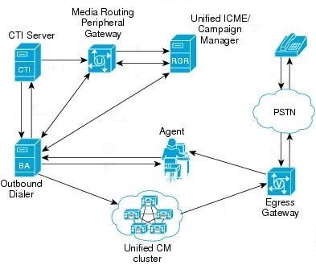

**Vytalize**

**CVT**

**Processes Model**

|  |  |  |  |  |  |
| --- | --- | --- | --- | --- | --- |
| **Process** | | **Objectives** | | **Actions / Deliverables** | |
| **New Variable Set** | | **SD:** | **DD:** |
| <Database Name> **: Set Description** | |  | | * A: * D: | |
| **DB** | | **Resources** | | **Constrains** | |
|  | |  | |  | |
| **Owner** | **Stakeholder** | | **Platform** | | |
|  |  | |  | | |

SD – Start Date

DD – Deploy Date

**IPO Model**

|  |  |  |  |  |  |
| --- | --- | --- | --- | --- | --- |
| **Input** | **Objective** | **Action** | **Output** | **Owner** | **Frec.** |
|  |  |  |  |  |  |
|  |  |  |  |  |  |